IT FND 110A

Yizhou Yang

Prof. Randal Root

TA: Aayush V. Shah

August 10, 2020

Assignment 05

<https://github.com/effyyangdesign/IntroToProg-Python>

Assignment 05 Step Documentation

**Introduction**

This essay documents the steps I took to finish Assignment 05: create a python program allows user to control and manipulate a to-do list

**Steps**

Base on the suede-code provided, I decide to read the list and load the data into memory for further processing. By utilizing the code structure covered in “Lab5-2-Starter.py”, I ran a loop so I can get the data into a list format, then using the index of the list, I can put them into a series of dictionary rows. Once they are in the right format, I can put them into the 2-dimensional list table to store these dictionary rows. 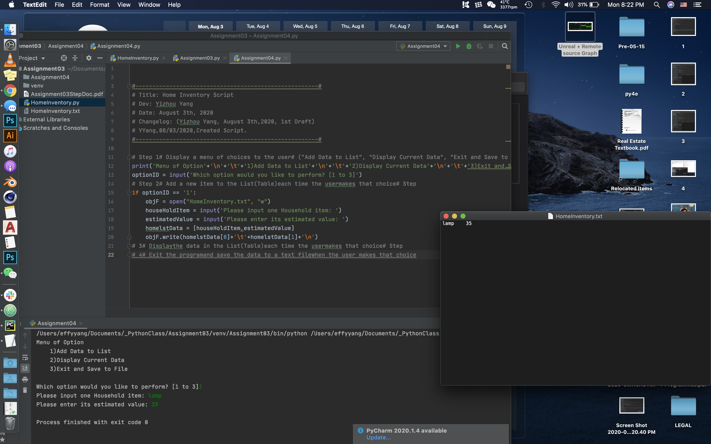

Then, I want to use the same loop mechanism to print 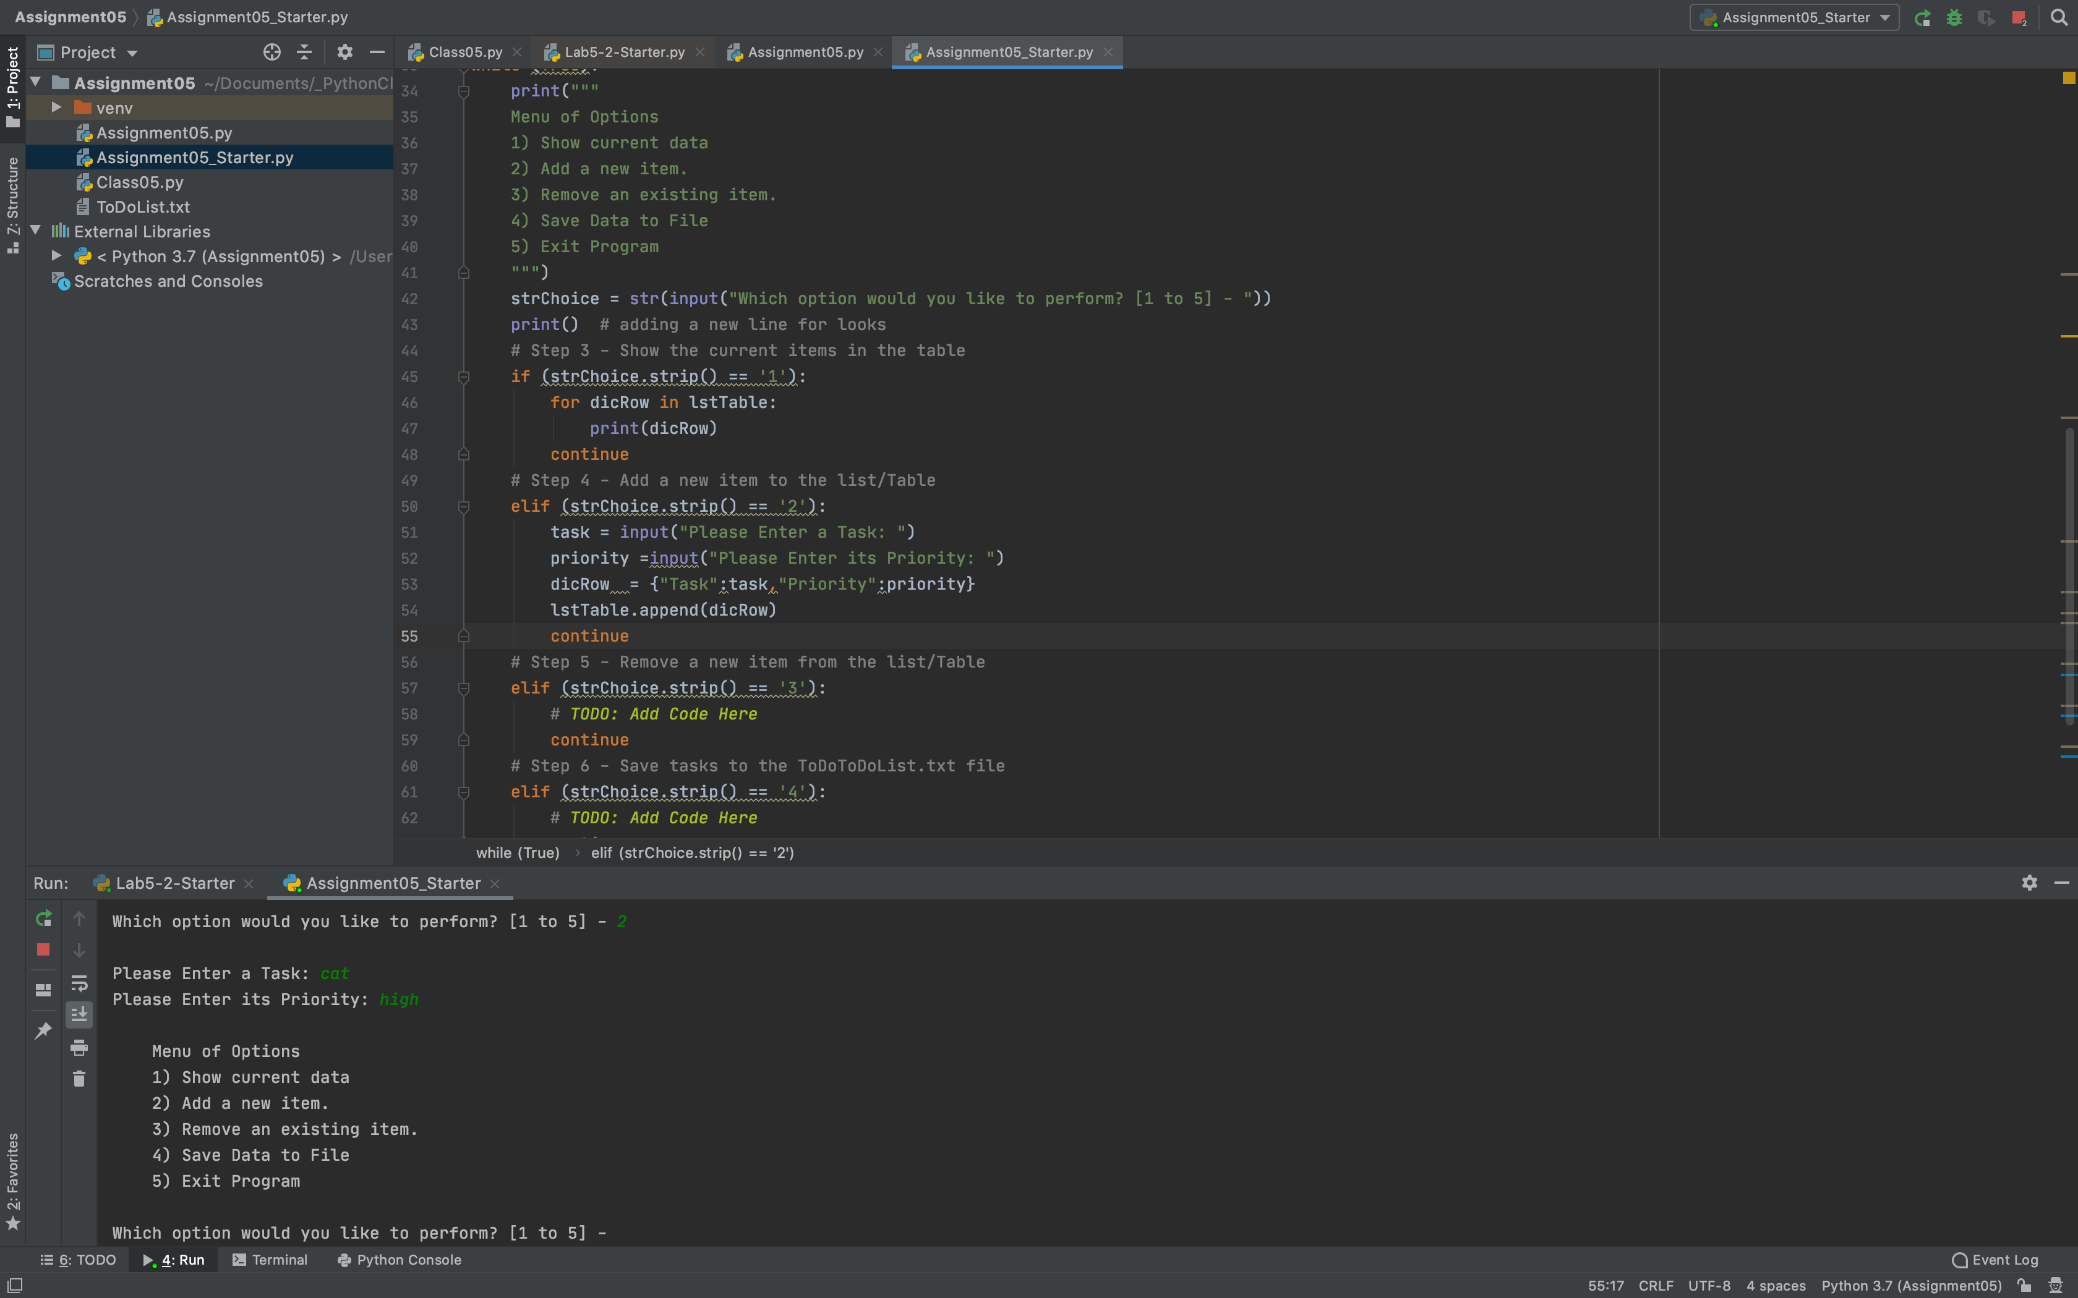out all dictionary rows when user selects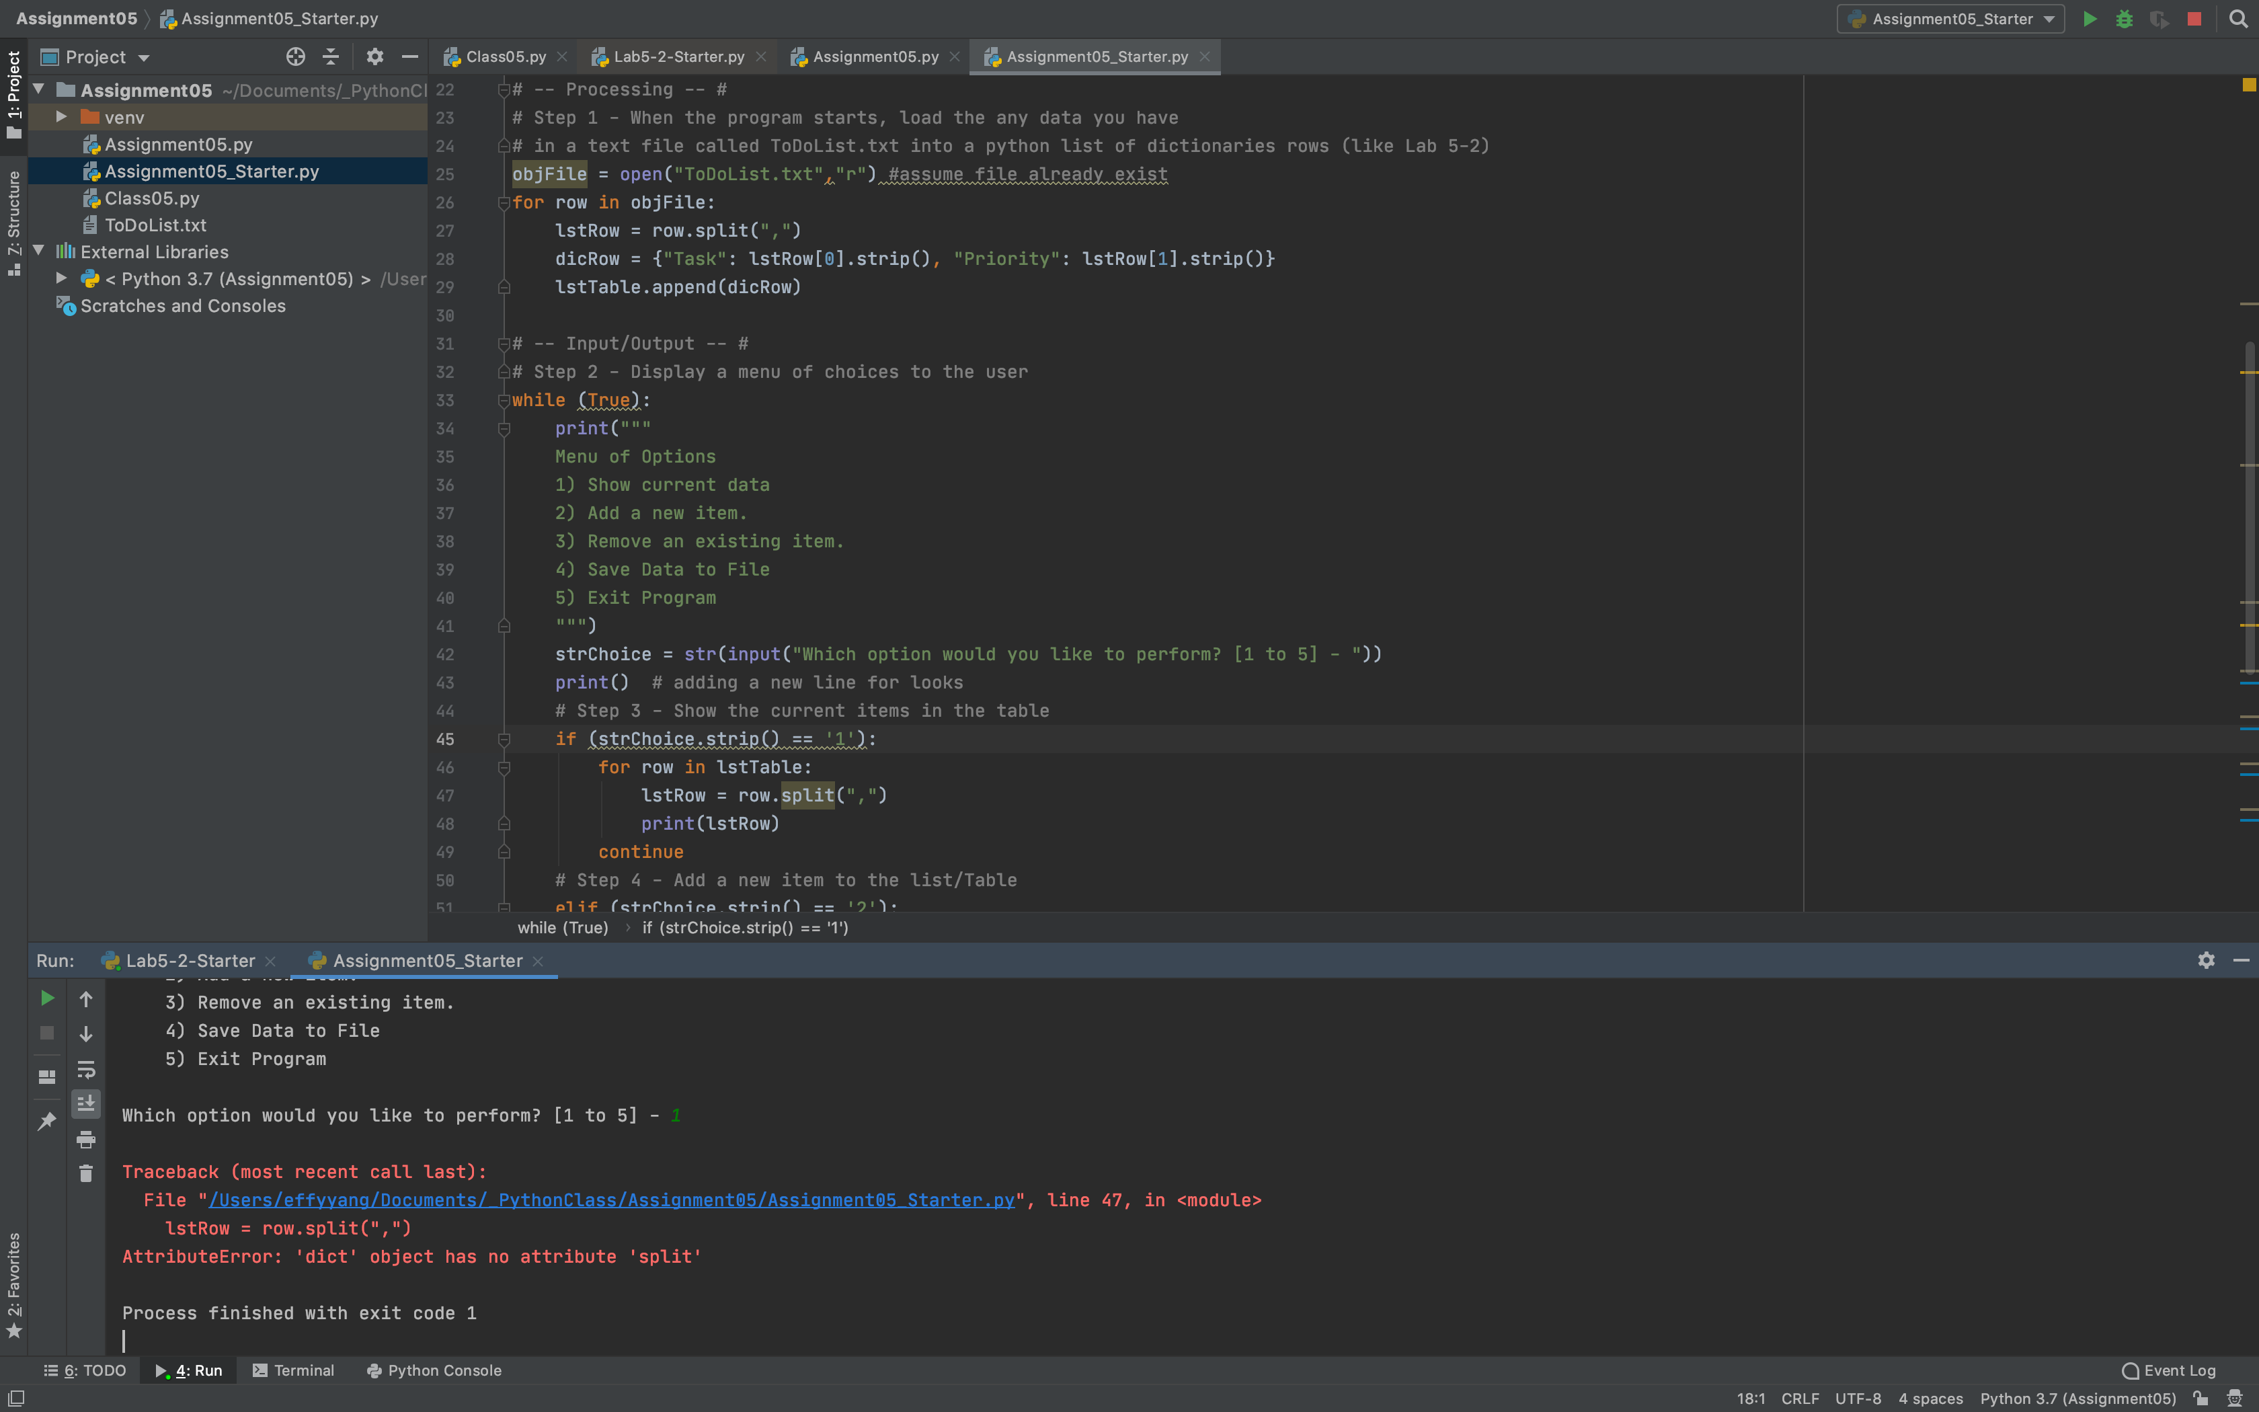 option (1).

I realized that since I have already loaded these data in lstTable as individual dictionary rows. Instead of putting them in a list, I can just print them directly. Then moving onto option (2), I asked for input, and put them in a new row of dictionary data and added that into the 2-dimenstional list table. I found the list.append(x) method in Mod4PythonProgrammingNotes.pdf on page 16.

For option (3), I decided to display everything so the user can reference them to choose which one to delete, so I copied option (1)’s code, and added a request for input. Once the user enters task, I can look it up in the dictionary. If there is a match, then I can delete it. Referring back to Module4’s notes. I corrected delete to list.remove(x).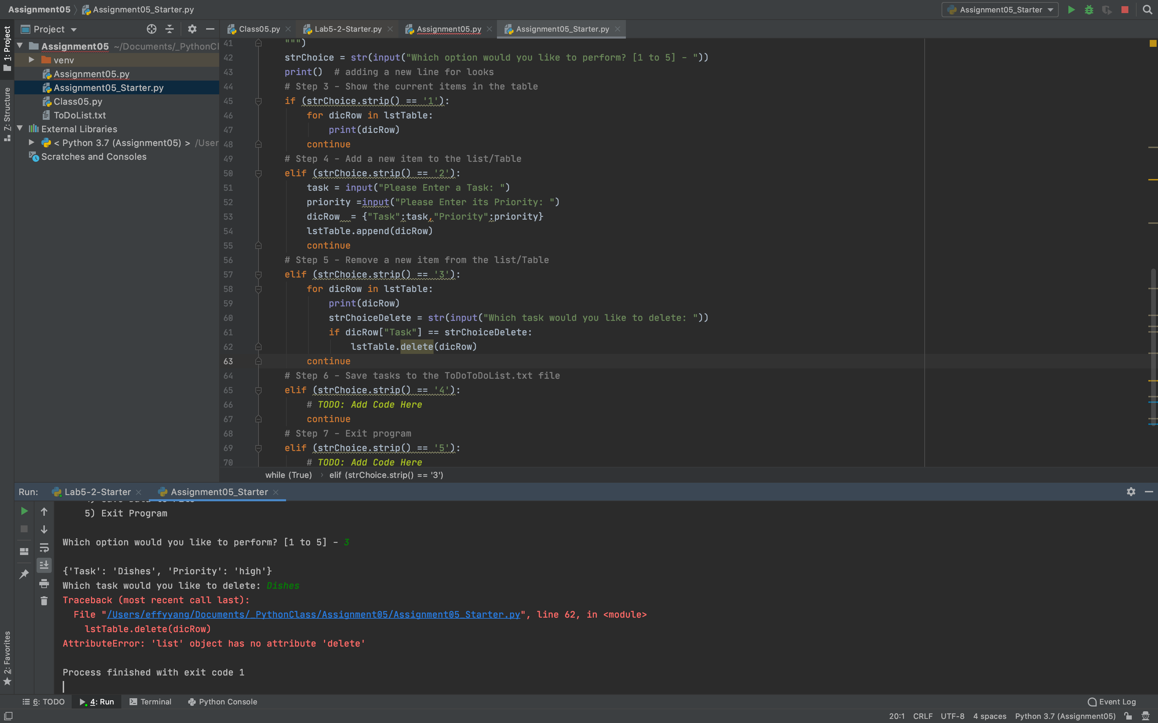

I also added an else statement to prompt user to input again if no match was found. 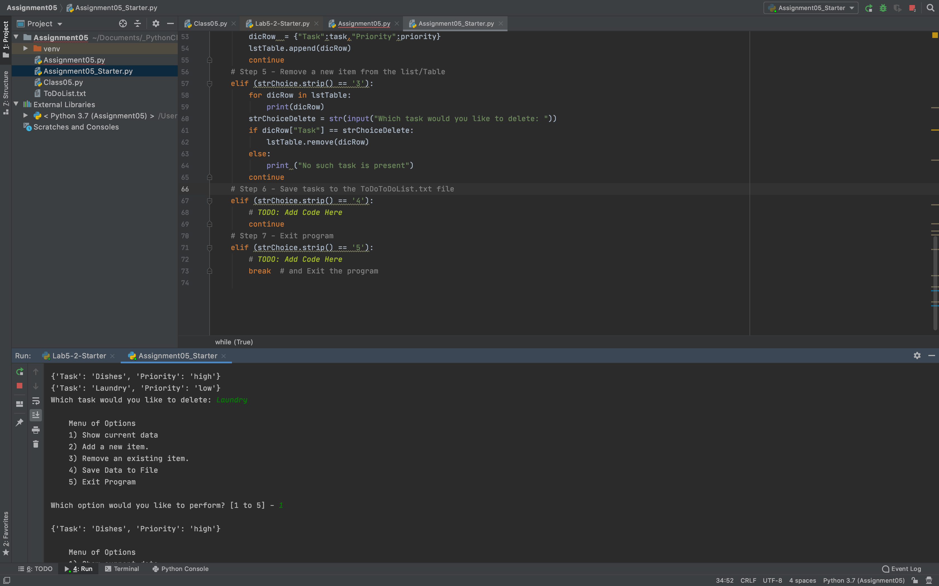

I was still quite confused about the relationship among list, dictionary row the file. I made the same mistake again here but I quickly realized that this step has already been done in the beginning of the program. This step just need to write the data from memory to file by referencing the dictionary row.

After fixing option (4). I just added a greeting exit for option (5).

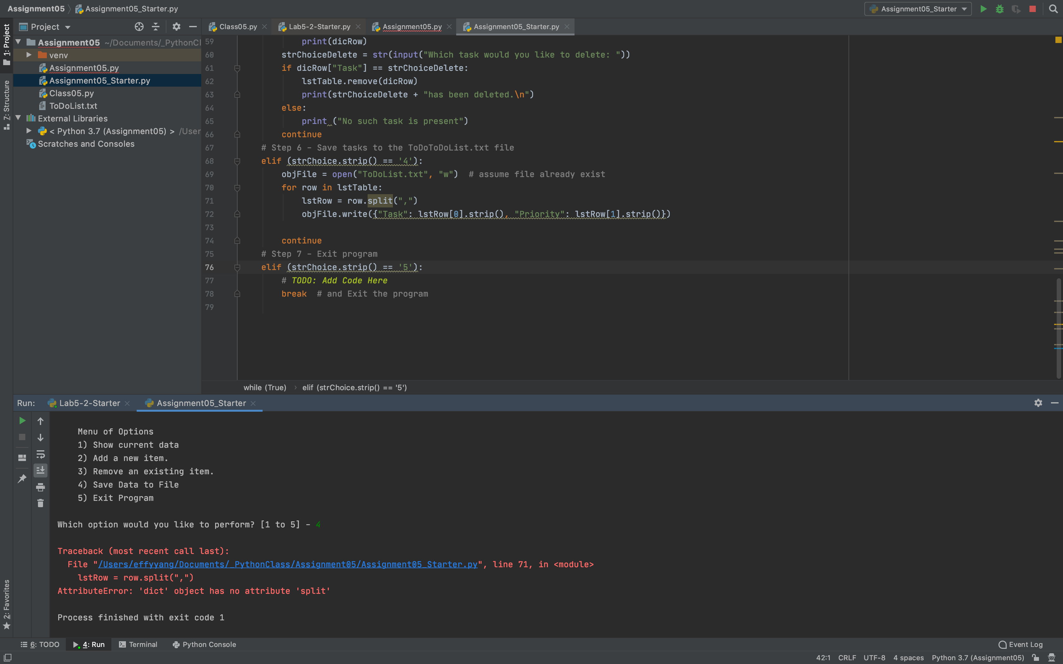

**Summary**

The whole assignment made me much clearer on the concept of memory and file, and different between dictionary and list. I think I need more practice to master the concept still.